Soil Moisture Sensor

CS120B Custom Project Final Report

Winter Quarter 2019

Samuel Liu

SID: 861270589

Table of Contents

[**Introduction:**](https://docs.google.com/document/d/1-xy6VmtY8k6tF-gSGBFLczn0Hhce3uhBp-F_ejkmoHQ/edit#heading=h.n9o44neiquk5)  3

**User Guide:** 3

**Special Considerations:** 3

[**Technologies Used:**](https://docs.google.com/document/d/1-xy6VmtY8k6tF-gSGBFLczn0Hhce3uhBp-F_ejkmoHQ/edit#heading=h.vqmbsuo5p330)  3-4

**Source Files:** 4

**Complexities:** 5

**Youtube Link:**  5

**Known Bugs:** 5

**Future Goal:** 5

**Technologies Learned:** 5-6

Introduction

This device will read moisture levels in the soil using a soil moisture tester. The LCD will display moisture information, while the LED Matrix will provide a visual on the moisture readings by increasing or decreasing the LED light rows. The joystick is used to change the display between soil moisture percentage and a display of whether or not the ground is dry or muddy.. The machine will operates on a 1 second tick to ensure real-time measurements. This device is also capable of storing the last recorded measurement before the device is turned off. This information is displayed at the start of the machine’s activation. There is also a sound buzzer that will increase or decrease in frequency according to the moisture reading.

User Guide

In order to use this device, the power first must be plugged in to ensure that the device will be working properly. Once the device is turned on, the LCD should flash the last recorded moisture level if used before. In order to obtain soil moisture, the user must first put the soil tester (red color) into soil to begin the soil moisture measuring. The measurement should then be output to the LED Matrix, Sound Buzzer, and LCD Screen within a second of placement. In order to change the LCD display, the user must hold the joystick left to view the screen. If the user wishes to keep it at the Dry or Muddy display, the user must continue to hold the joystick. If not, the user is free to let go of the joystick and the screen will return to the moisture percentage display.

***Special Considerations*:**

While not a new function or feature, the sound buzzer’s usage was primarily for debugging. However, the sound buzzer also functions so that people with certain disabilities or vision impairment can also use the device to find out the particular soil moisture in a given sample.

Technologies Used

Parts List

* 2 axis Joystick
* Sound Buzzer
* 8x8 LED Matrix
* 2x16 LCD screen
* Soil Moisture Sensor
* EEPROM
* ATMEGA1284
* Atmel Studio 7.0
* Power Supply

Pinout:

* **Inputs**
  + Joystick
  + Moisture sensor
* **Outputs**
  + 2x16 LCD screen. This is used to display the soil conditions
  + Sound Buzzer. This is used to listen to the soil conditions
  + 8x8 LED matrix. This is used to visualize the soil moisture readings

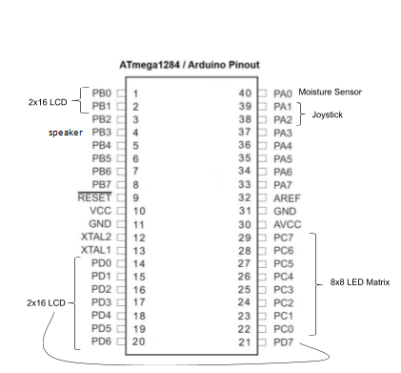

Source Files:

io.c and io.h : This .c/.h file allows for us to output characters to the LCD Screen/LED Matrix. Without it, we would not be able to output anything properly.

timer.h: This .h file aids our program’s ability to operate on a tick and allow us to time our program.

avr/eeprom.h: This .h file is a library that is already included within the Atmel Studio 7.0 within the avr folder. This allows us to use the EEPROM to save data and allocate bits for storage usage.

Complexities

* Implemented LED Matrix
* Implemented functional joystick
* Implemented and calibrated the Moisture sensor to function correctly
* Utilized EEPROM to save last recorded moisture level

YouTube Link

https://youtu.be/SoQsujZSyL8

Known Bugs

* Because the tick on the machine is one second, the joystick must be held for most of the tick in order for the input to be recognized by the machine.
* The joystick has issues reading tilts in the down and the right directions, potentially due to faulty manufacturing, so the device was made to only register tilts in the up and left directions.
* Timing of the machine is a bit finicky due to Atmel Studio issues, so while TimerSet is set to 125, in reality the refresh rate of the measurements are in one second tick intervals. (May be an issue with timing/clock settings)

Future Work

For the future, I hope to add in a temperature sensor that will work in conjunction with the soil moisture to give a prediction of the weather outside. I have already begun a bit of the temperature functionality, however due to time constraint I was only able to begin small parts of it. While not explicitly listed in my project proposal, adding in temperature is one of my own personal goals that I hope to continue in the next quarter or in the summer when I have more free time to properly work on this device with no time constraint for a deliverable.

Technologies Learned:

-Learned how to program and use an LED Matrix for display

-Learned how to utilize EEPROM to allocate bits and store data

-Learned how to read in analog values obtained from the soil moisture tester as well as wire and use the soil moisture tester

-Learned how to use a joystick as an input to determine which state the device will move onto next.